Introduction to Automotive

Report

Lab 7: TCS

|  |  |
| --- | --- |
| Student Name | Ahmed Mohsen Abd El Fattah |
| ID | 1901061 |

# TCS:

The traction control system aims to decrease wheel spinning, one the road if one of the wheels coefficient of friction with respect to the road changes its speed will vary from the other wheels, the traction control system keeps the speed of this wheel almost the same as the other wheels.

# MATLAB Snippets:

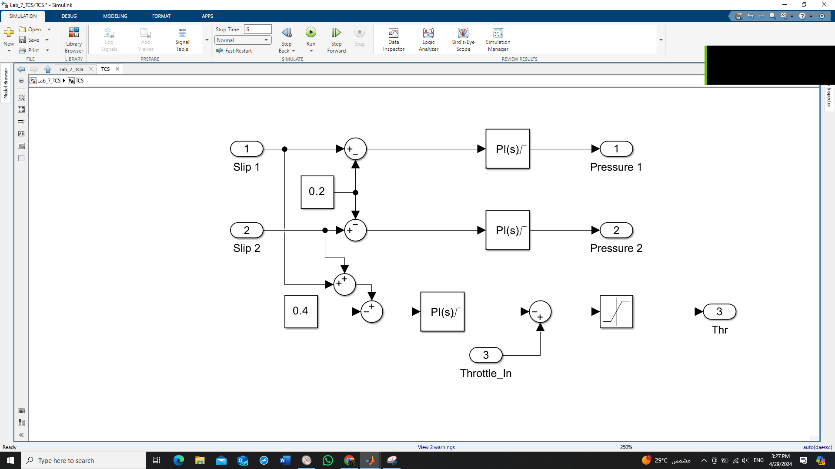

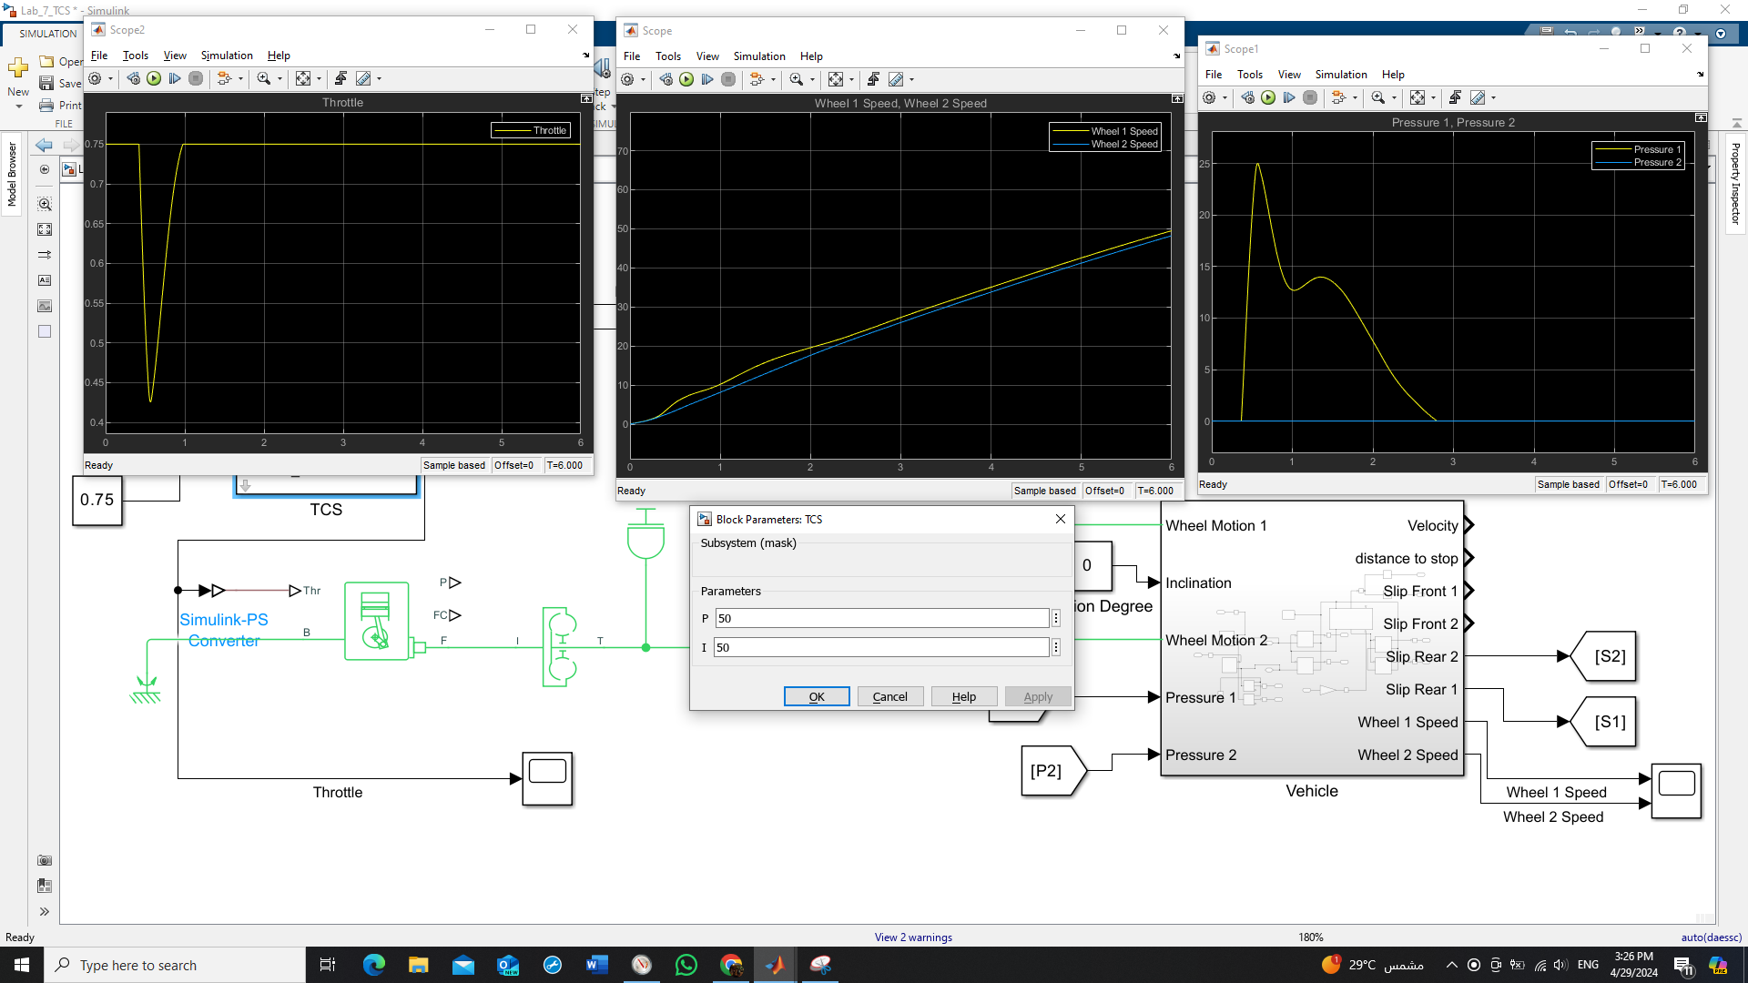

# Comments:

* The coefficient of friction of one of the driving rear wheels with the road is half the other wheel.
* The TCS intervened to lower the speed difference between the two wheels by applying brake pressure on wheel 1 which is the faster wheel.